www.pjkd.com.pk
Case Report

Vasculitis with Renal Involvement in Mixed Essential Cryoglobulinemia

Sajid Islam Bhatti, Tajammul Waqar, Shafique Younus, Sidra German

Department of Nephrology,
Sindh Institute of Urology and Transplantation (SIUT),
Karachi, Pakistan

Abstract:
Cryoglobulins are proteins that precipitate individual’s serum or plasma at temperatures lower than 37°C. It could be due to immunoglobulin and complement component or immunoglobulin alone. They produce physical finding of ischemia, inflammation in areas of low temperature (skin, ear lobes, nose and fingers), and of high protein concentration (glomeruli) especially at high concentration in plasma. We report here a case of middle-aged male who presented with worsening of pedal edema, high blood pressures and shortness of breath. On workup found to have nephrotic range proteinuria. Renal biopsy done which showed mesangiocapillary glomerulonephritis with hyaline thrombi. After biopsy report cryoglobulins were sent which turn out to be positive and patient was subjected to immunosuppression to which he responded well. However; we could not find out the cause of cryoglobulinemia hence we labeled it as mixed essential cryoglobulinemia.

Keywords: Mixed essential cryoglobulinemia (EMC), mesangiocapillary glomerulonephritis, HCV, pupura, vasculitis.

Corresponding Author:
Sajid Islam Bhatti,
Dept of Nephrology,
SIUT, Karachi. Pakistan
Email: sajidibhatti@gmail.com
sajidibhatti@yahoo.com
DOI:

Received April 26, 2023 and accepted Oct 27, 2023 PJKD 2024;8(1):

Introduction:
Cryoglobulinemic vasculitis is a systemic vasculitis that affects predominantly skin, joints, peripheral nerves and kidney. It precipitates at temperature cooler than core body temperature.¹ There is a great geographical heterogeneity in its prevalence. The disease is more common in Southern Europe than in Northern Europe or Northern America.² According to the World Health Organization (WHO), there are 7 million people living with chronic HCV infection in the Americas, with an incidence rate of 6.4/100,000 in 2015.³ According to Brouet there are 3 type of cryoglobulinemia. Type1 to type3. Chronic hepatitis C virus (HCV) infection accounted for 80–90% of cases of mixed cryoglobulinemia, before the era of direct acting antivirals (DAA). At that time connective tissue disease and B-cell malignancies among the cases of non-related-HCV cryoglobulinemia appeared as the leading causes. The remaining non HCV-related cases are classified as having essential cryoglobulinemia.⁴ We present here a case of middle age male having mixed essential cryoglobulinemia.

Case Presentation:
52-year-old male patient, resident of, by occupation he has an indoor office work in a state based department. He had no known prior co-morbid, was in good state of health till about 1 year back when he developed lower limb pain and swelling. Work up done found to have varicose vein so ligation done in September 2022. In December 22 he presented with complaint of g headache, excessive pedal swelling extending up to shins landed in emergency of Aga Khan hospital There was no history of seizure, weakness of limbs , easy fatigability frothy urine, rashes, oral ulcer, photosensitivity, unusual hair fall, hematuria, hemoptysis and joint pain. Past surgical history of appendectomy in 1982, inguinal hernia repair in 2012 and varicose vein ligation in recent past. Family history is significant for diabetes and ischemic heart disease to father. Patient was nonsmoker and not addicted to any recreational substance. During his visit in emergency blood pressures were found to be raised 140/100 mm Hg. Weight 60kg with bilateral pedal edema and chest was clear on auscultation, there was no gallop and abdomen and central nervous system examination normal. Laboratory investigations before presenting to AKU hospital, showed proteinuria of 4836 mg in 24 hour with serum creatinine of 1.3 mg/dl and serum albumin of 2.4g/dl. Renal biopsy was done on 13th December 22, revealing mesangiocapillary glomerulonephritis (MPGN). IF showed IgG + peripheral and mesangial, IgA + peripheral and mesangial, IgM ++ peripheral and mesangial, C3++ peripheral and mesangial, c1q + peripheral and mesangial. He was started on oral prednisolone in dose of 60mg/day and combination of valsartan with amlodipine started along with furosemide

The patient first time presented in our outpatient department on 24th December 2022 with pedal swelling and raised pressures of 148/101. As previously mentioned, there was no associated complain and his systemic examination was significant for pedal edema only. He was advised to continue same treatment and follow up in 4 weeks. Patient came back after 2months in February 2023. His repeat workup at SIUT revealed, serum creatinine of 0.8mg/dl and serum albumin 3mg/dl. Viral markers Hepatitis B antigen and Anti HCV were negative including HCV RNA not detected. ANA and AntidsDNA were negative, C3 0.9 g/L(0.8-1.5g/L) and C4 0.1g/L(0.12-0.39g/L). Chest x-ray normal, ultrasound abdomen showed normal size kidney, liver and spleen were normal size and texture. Echocardiography showed LV hypertrophy with grade 1 diastolic dysfunction Ejection fraction 70%. Steroids were abruptly tapered and he relapsed in April 2023 with serum creatinine of 1.5mg/dl and serum albumin 2g/dl. At first relapse oral prednisolone was increased to 70mg/day. Meanwhile, workup of paraproteinemia was sent. Mycophenolate Mofetil 750 mg in twice daily dosage was started and dose of prednisolone reduced by 50 percent. Serum protein electrophoresis showed no monoclonal band and free light chain assay was normal 1.6 (0.37-3.13mg/dl). After adding mycophenolate mofetil, serum creatinine dropped to 1.2 and albumin achieved was 3.2g/dl. Table 1 displays the of serial record of laboratory parameters and immunosuppressive medications.

Table1: Laboratory parameters and immunosuppressive medications prescribed for the patient over the course of disease.

 | Dec 2022 | Feb 2023 | April 2023 | May 2023 | Jul 2023 | Aug 2023
Urine (protein/RBC) | 3+/nil | 3+/3+ | 3+/3+ | 3+/2+ | 3+/3+ | 3+/2+
UPCR |  |  |  | 1.68 | 3.58 | 3.5
S/Creatinine (0.5-1.2 mg/dl) | 1.3 mg/dl | 0.82 mg/dl | 1.5 mg/dl | 1.54 mg/dl | 1.3 mg/dl | 1.13 mg/dl
Serum Albumin (3.5-5 G/dl) | 2.4 G/dl | 3.0 |  | 2.9 | 2.9 | 2.9
Serum Calcium (8.4-10.2mg/dl) | 8.05 | 8.93
Hemoglobin (13-16.5g/dl) | 11.9 | 12.4 | 9.9 | 10.15 | 10.4 | 10.4
WBC (4-11x10⁹/L) | 12.9 | 8.4 | 6.7 | 11.4 | 11.3 | 11.3
Platelets (150-450x10⁹) | 375 | 251 | 278 | 279 | 298 | 298
Treatment Course | Kidney Biopsy | PSL | PSL+ MMF | PSL+ MMF | PSL+ MMF | PSL+ MMF
PSL= prednisolone, MMF= Mycophenolate Mofetil, UPCR=urinary protein to creatinine ratio

He was admitted at outside facility for pneumonia and serum creatinine rose from 1.2 to 4.9mg/dl patient was admitted from OPD in sept 23 for the worsening of renal functions. Again acute kidney injury workup sent and urinalysis revealed protein 2+ and numerous RBC. Ultrasound abdomen and doppler done for renal vein thrombosis and was normal. A repeat kidney biopsy was done on 22 September 2023 which showed 18 glomeruli of these 2 are globally sclerosed rest show mesangiocapillary pattern with florid hyaline thrombi in capillary lumena and focal cellular crescents in 2 glomeruli, Figure 1. IF complete panel was negative in sclerosed glomeruli. Repeat complement levels showed low C4 0.012g/L (0.12-0.39g/L) and normal C3 0.92g/L (0.8-1.5g/L). After biopsy he was prescribed intravenous cyclophosphamide due to crescents and deranged renal functions. Having hyaline thrombi in biopsy and significantly low C4 level as compared to C3, cryoglobulin were requested which turn out to be 3.6%. Keeping in mind other differential of hyaline thrombi we sent ENA profile and APLA they are negative as well. HRCT was also normal
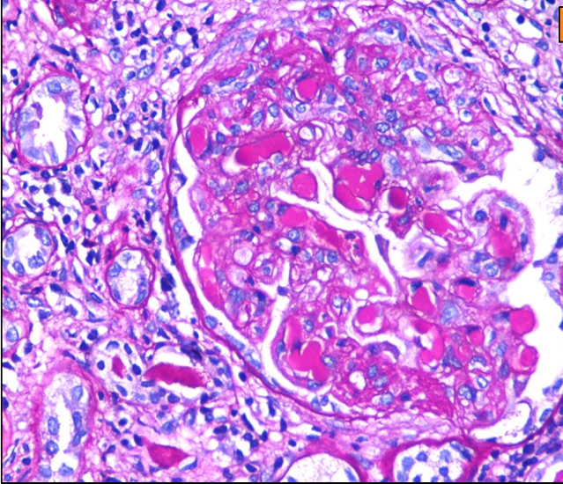
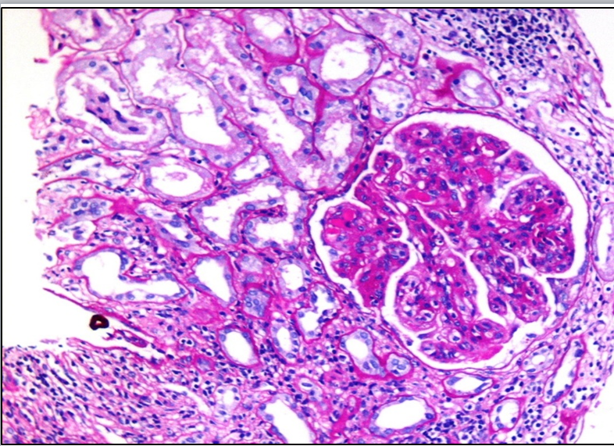
a)
b)

Fig 1 (a) and (b): Renal biopsy showing lobulated glomeruli, with endocapillary proliferation a), capillary lumena obliterated, pink glassy amorphous material inside the capillary lumena is indicating hyaline thrombi with mild interstitial inflammation in background( b).

He was given oral prednisolone 0.5mg/kg along with rituximab 1g I/V on 20 Oct 23 and 2nd dose on 11 November 23. His serum creatinine improved to 1.5mg/dl and cryocrit 0.5%. He is advised to follow up as outpatient after 2 weeks. He will require close follow up as we still were able to diagnose any cause for cryoglobulinemia and therefore labeled as mixed essential cryoglobulinemia.

Discussion:
Cryoglobulins (CG) refers to abnormal proteins /immunoglobulin’s that precipitates in serum or plasma stored at temperature below 37° C and upon rewarming it dissolves.⁵ CG may be deposited in medium and large vessels throughout the body causing endothelial injury and end organ damage then it is known as Cryoglobulinemia.⁶ It can be associated with infection, autoimmune disorders, and malignancy. In the absence of detectable cause, it is termed as idiopathic or essential mixed cryoglobulinemia (EMC).⁷ It has wide range of manifestation from mild to severe disease, which include purpuric skin lesion, arthralgia, neuropathy, and glomerulonephritis.⁸ The triad of arthralgia, purpura and asthenia is also known as (Meltzer-Franklin triad).⁹

Brouet et al immunochemically classified CGs into three types. Type I contains an isolated monoclonal Ig; type II comprises IgG and an IgM rheumatoid factor (RF) of monoclonal origin, and type III comprises IgG and a polyclonal IgM RF.¹⁰ Type I cryoglobulins are single monoclonal immunoglobulins and are always associated with malignant hematologic disorder (25%). Type II and III are mixed cryoglobulins, composed of different immunoglobulins, with a monoclonal component in type II and only polyclonal immunoglobulins in type III. Mixed cryoglobulins (type II or III) are associated with connective tissue disease, malignant hematologic disorders, or obvious infectious process (hepatitis B, hepatitis C, Epstein-Barr virus, human immunodeficiency virus, cytomegalovirus, Leishmania, Treponema, leprosy and candidiasis). When mixed cryoglobulins are found in the absence of well-defined disease, the syndrome has been designated essential mixed cryoglobulinemia.¹¹ Hepatitis C became recognized as the major cause of CG formation in early 1990s, with approximately 90% of MC patients having the virus. Approximately 50% of HCV-infected patients develop CGs in their blood.¹²

For the detection of cryoglobulins, it requires accurate temperature control while it is collected, and until the serum is separated. CG are immunoglobulins that reversibly precipitate below 37°C, thus, to avoid premature cryoprecipitation, the blood sample must be kept at 37° during transport to the laboratory and during centrifugation. After centrifugation, the serum sample is stored at 4°C for 8 days to ensure detection of delayed cryoprecipitation.⁹

Treatment of cryoglobulinemia depends on the type of disease. In secondary cryoglobulinemia, treatment of the underlying disease is crucial. In type 1 cryoglobulinemia with lymphoproliferative disorder, treatment with chemotherapy usually reduces immunoglobulin levels and their contribution to hyper viscosity syndrome. On the other hand, in mixed cryoglobulinemia (type II and type III), treatment strategy is mainly based on anti-inflammatory and immunosuppressive therapies.¹³

The introduction of direct acting antivirals (DAA) agents has radically transformed the management of HCV-related MC, allowing a shorter treatment regimen. HBV replication can be inhibited by nucleoside analog in 90-100% of cases. Mild to moderate cryoglobulinemic vasculitis patients show clinical response on nucleoside analog, and in refractory cases rituximab can be considered along with nucleoside analog treatment.⁹ B cell depletion with Rituximab is most promising approach for cryoglobulinemic vasculitis. Peripheral B-cell depletion should lead to a reduction in the B-cell clones that produce cryoglobulins.¹⁴ Double filtration plasmapheresis is done when there is severe renal impairment, skin necrosis, intestinal ischemia, cardiac or central nervous system vasculitis.¹⁵

Conclusion: Our patient with mixed essential cryoglobulinemia responded to immunosuppressive medications including cyclophosphamide. Measurement of cryoglobulins although difficult can be performed in coordination with the clinical pathologist resulting in proper diagnosis and proper management.

References :
- Coorey CP, Aarabi A, Kumar K. Mixed cryoglobulinemia vasculitis secondary to marginal zone lymphoma in a patient with end-stage renal failure on haemodialysis. CEN Case Reports. 2023;6:1-6.

- Ferri C. Mixed cryoglobulinemia. Orphanet Journal of Rare Diseases. 2008;3:1-7.

- Freitas-de Aguiar M, Faria-Janes AL, Garcia-Brandes GI, Takemi-Emori C, Gomes-Ferraz ML, Coelho-Andrade LE, et.al. Prevalence of cryoglobulinemia and cryoglobulinemic vasculitis in chronically HCV-infected Brazilian patients. Annals of Hepatology. 2019;18(5):685-92.

- Boleto G, Ghillani-Dalbin P, Musset L, Biard L, Mulier G, Cacoub P, Saadoun D. Cryoglobulinemia after the era of chronic hepatitis C infection. InSeminars in Arthritis and Rheumatism 2020;50(4):695-700.

- Wheeler RD, Sharma H, Groves M, Wren D, Sheldon J. A case study of mixed cryoglobulinemia associated with peripheral neuropathy. Annals of clinical biochemistry. 2007;44(6):566-9.

- Bhandari J, Awais M, Aeddula NR. Cryoglobulinemia. [Updated 2022 Aug 10]. In: StatPearls [Internet]. Treasure Island (FL): StatPearls Publishing; 2024 Jan-. Available from: https://www.ncbi.nlm.nih.gov/books/NBK557606/.

- Dammacco F, Lauletta G, Vacca A. The wide spectrum of cryoglobulinemic vasculitis and an overview of therapeutic advancements. Clinical and Experimental Medicine. 2023;23(2):255-72.

- Túlio M, Carvalho L, Bana E Costa T, Chagas C. Mixed cryoglobulinemia: a diagnostic and therapeutic challenge. BMJ Case Rep. 2017:bcr2017219768.

- Treppo E, Quartuccio L, De Vita S. Recent updates in the diagnosis and management of cryoglobulinemic vasculitis. Expert Review of Clinical Immunology. 2023;24:1-1.

- Silva F, Pinto C, Barbosa A, Borges T, Dias C, Almeida J. New insights in cryoglobulinemic vasculitis. Journal of Autoimmunity. 2019;105:102313.

- Cacoub P, Costedoat-Chalumeau N, Lidove O, Alric L. Cryoglobulinemia vasculitis. Current opinion in rheumatology. 2002;14(1):29-35.

- Anis S, Abbas K, Mubarak M, Ahmed E, Bhatti S, Muzaffar R. Vasculitis with renal involvement in essential mixed cryoglobulinemia: Case report and mini-review. World Journal of Clinical Cases: WJCC. 2014;2(5):160

- Ostojic P, Jeremic IR. Managing refractory cryoglobulinemic vasculitis: challenges and solutions. Journal of Inflammation Research. 2017;10:49-54.

- Perez-Alamino R, Espinoza LR. Non-infectious cryoglobulinemia vasculitis (CryoVas): update on clinical and therapeutic approach. Current rheumatology reports. 2014;16:1-6.

- Naciri Bennani H, Banza AT, Terrec F, Noble J, Jouve T, Motte L, et.al. Cryoglobulinemia and double‐filtration plasmapheresis: Personal experience and literature review. Therapeutic Apheresis and Dialysis. 2023;27(1):159-69.

