www.pjkd.com.pk
Original Article

Compliance with Anemia Management Indicators Among Maintenance Hemodialysis Patients: A Clinical Audit from a Tertiary Center

Mehadi Hasan, Ebadur Rahman, A.F.M. Noman, Ummay Farwa Hoque, Asma Jalal Panjery, Md. Mahbubur Rahman, Rubiya Rahim

Department of Nephrology, Evercare hospital, Dhaka, Bangladesh

Abstract
Background Anemia is a major complication among patients with end-stage renal disease (ESRD) receiving maintenance hemodialysis (MHD). Effective management requires consistent adherence to guideline-recommended practices, including hemoglobin monitoring, iron assessment, and appropriate erythropoiesis-stimulating agent (ESA) titration. This audit aimed to evaluate compliance with key anemia management indicators in a tertiary hemodialysis unit.
Methods A cross-sectional clinical audit was conducted among 62 adult MHD patients at Evercare Hospital Dhaka. Data were collected using a structured checklist based on KDIGO 2021 anemia guidelines. Eight indicators were assessed: anemia screening, iron status documentation, correction of iron deficiency, post-ESA hemoglobin monitoring, maintenance of target hemoglobin, quarterly iron profile checks, ESA dose adjustments, and completion of patient education. Compliance levels were analyzed descriptively and compared across genders.
Results High compliance (82–100%) was observed in anemia screening, ESA dosing, post-ESA hemoglobin monitoring, and patient education. Hemoglobin maintenance within target ranges showed moderate adherence (62.9%). Iron documentation (35.5%) and quarterly iron monitoring (8.1%) demonstrated critically low compliance. Male patients achieved better hemoglobin control than females (80.8% vs. 50%). A strong positive correlation was found between appropriate ESA titration and hemoglobin stability.
Conclusion The audit identified strong adherence to ESA-related processes and patient education but highlighted major gaps in iron assessment and routine monitoring. Strengthening iron management practices is essential to optimize anemia outcomes in MHD patients. Targeted quality-improvement interventions are recommended to enhance overall compliance and align practice with international standards.
Key Words: Anemia, compliance, clinical audit, iron deficiency, erythropoietin,hemodialysis, end stage kidney disease.
Corresponding Author
Dr. Rubaiya Rahim
Department of Nephrology, Evercare hospital, Dhaka, Bangladesh
E-mail: rahimrubaiya24@gmail.com
DOI: 10.53778/pjkd101340
Received 25th Jan 2026 and accepted 27th March 2026 PJKD 2026;10(1):10-17

Introduction
Anemia remains a major clinical challenge in patients with end-stage renal disease (ESRD), particularly those receiving maintenance hemodialysis (MHD). It is primarily caused by inadequate erythropoietin production, chronic inflammation, and disordered iron metabolism, all of which contribute to impaired erythropoiesis and increased morbidity. ¹ Recent global evidence highlights that anemia in dialysis patients is strongly associated with fatigue, reduced functional capacity, cognitive impairment, and heightened cardiovascular risk, underscoring its importance as a therapeutic priority. ²
Over the past decade, advances in anemia management including refined dosing strategies for erythropoiesis-stimulating agents (ESAs) and improved approaches to iron supplementation have significantly shaped treatment pathways. ³ However, the success of these interventions relies heavily on adherence to standardized protocols. Timely hemoglobin monitoring, regular assessment of iron status, and accurate titration of ESAs remain essential components of effective anemia care, as emphasized in updated Kidney Disease: Improving Global Outcomes (KDIGO) recommendations. ⁴ Despite the availability of these guidelines, contemporary studies indicate persistent variability in clinical practice, often due to resource limitations, inconsistent documentation, and differences in clinician decision-making. ⁵

Clinical audit has emerged as a vital quality-improvement tool over the last decade, enabling dialysis centers to evaluate their performance against evidence-based standards and identify areas requiring corrective action.⁶ Through systematic assessment of key indicators such as screening rates, ESA dose adjustments, iron monitoring, and patient education, audits help bridge the gap between guideline recommendations and real-world practice.⁷ In resource-constrained settings, where disparities in anemia management are more prominent, regular audits are particularly important for strengthening clinical governance and optimizing patient outcomes.⁸

In Bangladesh and similar low-middle-income countries, recent studies highlight ongoing gaps in anemia care, including inadequate iron evaluation, inconsistent follow-up, and suboptimal hemoglobin control among MHD patients. ⁹ These issues reinforce the need for structured assessment to better understand current practices and guide improvement strategies at the facility level. Therefore, this clinical audit was undertaken to evaluate compliance with key anemia management indicators among patients receiving maintenance hemodialysis, with the primary objective of identifying strengths, deficiencies, and opportunities for enhancing quality of care.

Methodology
This study was conducted as a clinical audit using a cross-sectional design in the Hemodialysis Unit at Evercare Hospital Dhaka, a tertiary-level center providing maintenance hemodialysis (MHD) services to patients with end-stage renal disease (ESRD). The audit was carried out over a defined period, during which all available patient records were reviewed. The study population consisted of 62 adult ESRD patients undergoing maintenance hemodialysis for at least three months. Patients were included if their medical records contained complete documentation of anemia management indicators during the audit period. Individuals on temporary dialysis, those newly initiated (<3 months) on MHD, and patients with incomplete or missing data were excluded to ensure accuracy and consistency of the audit.

Data were collected after IRB approval letter number: ERC-79/2025-17 dated 29-12-2025, using a structured audit checklist developed according to the KDIGO 2021 anemia management guidelines. Relevant information was extracted from dialysis treatment sheets, laboratory databases, medication charts, and patient education records. The audit assessed eight key indicators: anemia screening, iron status documentation, correction of iron deficiency before ESA initiation, hemoglobin monitoring 2–4 weeks after ESA therapy, maintenance of hemoglobin within KDIGO targets, iron profile monitoring every three months, appropriateness of ESA dose adjustment, and completion of patient education. Both male and female patients were analyzed separately to identify differences in compliance patterns.

Data Analysis
Data were entered into a structured dataset and analyzed descriptively. Compliance with each indicator was expressed as frequencies and percentages. Correlation analyses were performed to evaluate the relationship between ESA dose adjustments, hemoglobin maintenance, iron monitoring, and other anemia management indicators. Findings were compared with established audit standards to identify strengths and quality gaps.

Result:
Figure 1 shows distribution of respondents according to gender. Male patients accounted for 56.45% and females 43.55%, indicating a slightly higher proportion of men undergoing MHD. This gender pattern aligns with global ESRD trends.

Figure 1: Distribution of respondents according to gender (n=62)
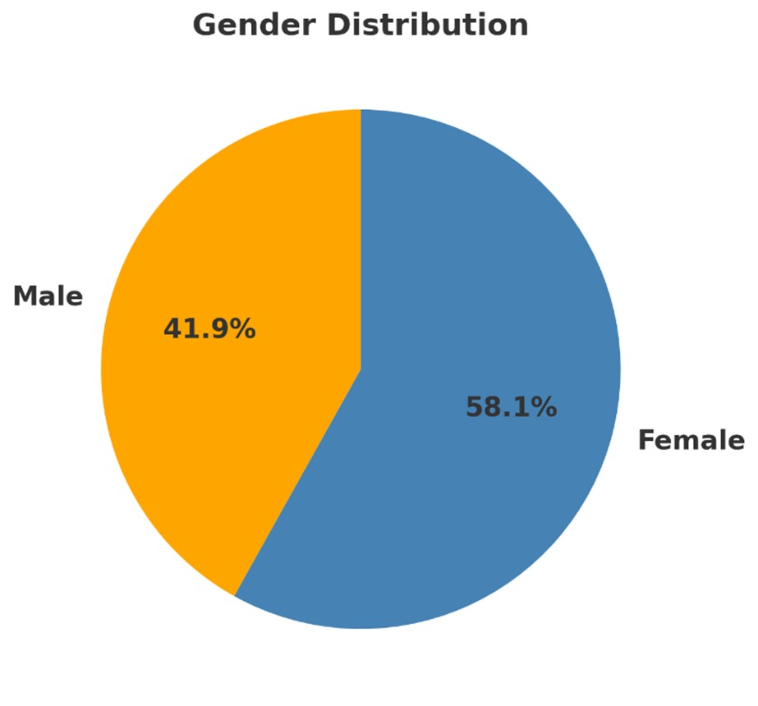

Figure 2 shows the distribution of patients according to age group. Majority of patients (69.35%) were aged ≥60 years, indicating that older adults form the predominant group undergoing MHD.

Figure 2: Distribution of patients according to age group (n=62)
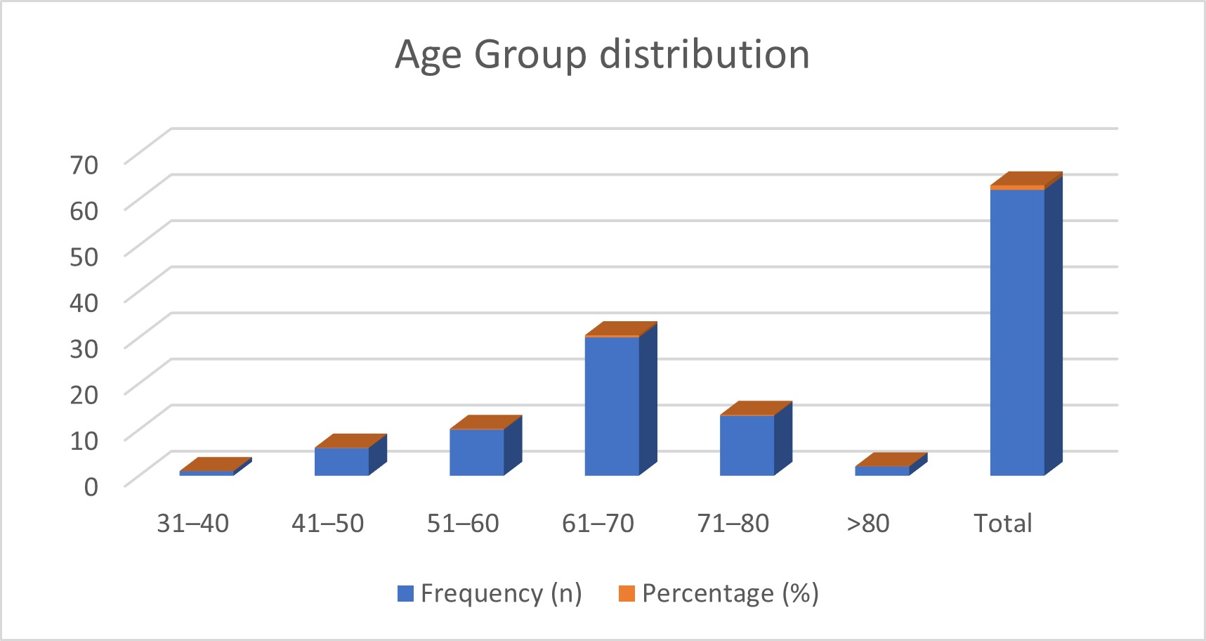

Table 1 illustrates distribution of patients according to patient’s compliance. High compliance (82–100%) was observed in screening, ESA dosing, post-ESA hemoglobin monitoring, and patient education, indicating strong adherence to core anemia management processes. Hemoglobin maintenance showed moderate compliance (62.9%), while iron documentation and monitoring remained low (8–35%).

Table 1: Distribution of patients according to patient’s compliance (n=62)

Category | Area | Compliance
High | Screening, ESA dosing, Hb post-ESA, Education | 82–100%
Moderate | Hb within KDIGO | 62.9%
Low | Iron documentation & monitoring | 8–35%

Table 2 showed excellent performance in anemia screening, iron deficiency correction, Hb monitoring post-ESA, and patient education across both sexes (≥96%). However, iron status documentation remained low (34–36%), and quarterly iron profile monitoring was critically poor (3.8–11.1%). Notably, males demonstrated better Hb maintenance within KDIGO targets (80.8%) compared with females (50%), indicating sex-based variation in treatment outcomes.

Table 2: Compliance with Clinical Audit Indicators (n=62)

Audit Indicator | Male n(%) | Female n(%)
Patients screened for anemia | 26 (100%) | 36 (100%)
Patients with documented iron status | 9 (34.6%) | 13 (36.1%)
Iron deficiency corrected before ESA | 23 (88.5%) | 31 (86.1%)
Hb monitored 2-4 weeks after ESA initiation | 25 (96.2%) | 36 (100%)
Hb maintained within KDIGO range | 21 (80.8%) | 18 (50%)
Iron profile checked every 3 months | 1 (3.8%) | 4 (11.1%)
ESA dose adjusted appropriately | 19 (73.1%) | 32 (88.9%)
Patient education completed | 25 (96.2%) | 36 (100%)

Figure 3 illustrates that anemia screening, patient education, and post-ESA hemoglobin monitoring achieved near-perfect compliance (98–100%), reflecting strong adherence to essential care processes. ESA dose adjustment (82.3%) and iron deficiency correction (87.1%) showed good but improvable performance. The lowest compliance was observed in iron documentation (35.5%) and quarterly iron profile monitoring (8.1%), identifying iron management as the most critical gap requiring intervention.

Table 3 shows a heatmap-based correlation analysis identified several significant associations among key anemia management indicators. ESA dose adjustments exhibited a strong positive correlation with hemoglobin (Hb) maintenance (r > 0.70), underscoring the pivotal role of precise ESA titration in sustaining target Hb levels. Iron profile monitoring and patient education both showed moderate positive correlations (r ≈ 0.50–0.55), reflecting that consistent iron assessment and informed patient participation contribute to improved treatment outcomes. Iron deficiency correction also moderately correlated with timely Hb monitoring (r ≈ 0.60), indicating that proactive iron management enhances follow-up adherence. Conversely, anemia screening demonstrated weak correlations (< 0.30) with other indicators, suggesting that screening alone is insufficient and must be complemented by effective monitoring and intervention strategies to optimize anemia management.

Figure 3: Anemia management metrics (n=62)
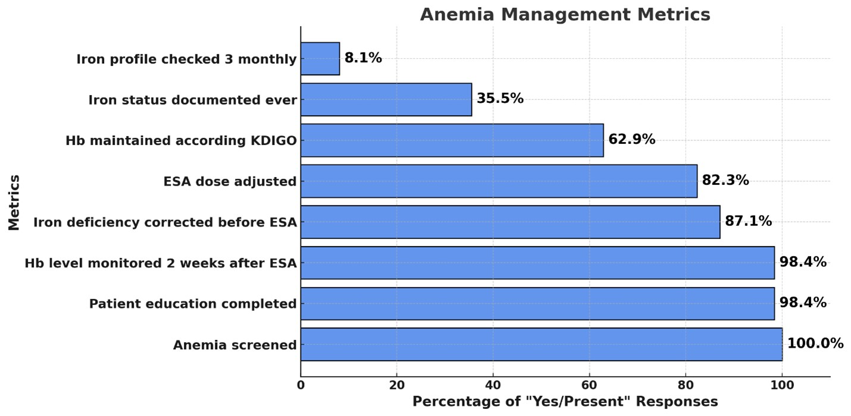

Table 3. Correlation Analysis of Key Anemia Management Indicators

Indicators Compared | Correlation Coefficient (r) | Strength & Direction
ESA dose adjustments vs. Hb maintenance | > 0.70 | Strong positive correlation
Iron profile monitoring vs. Hb maintenance | ≈ 0.50 | Moderate positive correlation
Patient education vs. ESA dose adjustments | ≈ 0.55 | Moderate positive correlation
Iron deficiency correction vs. timely Hb monitoring | ≈ 0.60 | Moderate positive correlation
Anemia screening vs. other indicators | < 0.30 | Weak correlation

Discussion
This clinical audit evaluated adherence to key anemia management indicators among patients receiving maintenance hemodialysis (MHD) and revealed a mixed pattern of strengths and gaps within the existing care processes. Overall, the results demonstrate high compliance in areas directly integrated into routine dialysis workflow—such as anemia screening, ESA titration, hemoglobin monitoring after ESA initiation, and patient education—yet substantial deficiencies persist in iron-related documentation and monitoring. These findings mirror trends reported globally over the past decade, particularly in low- and middle-income countries where anemia management practices remain highly variable.¹⁰⁻¹²

Near-universal screening for anemia and consistent monitoring of hemoglobin levels following ESA initiation align with international recommendations emphasizing the importance of timely assessment to ensure safe and effective therapy.^{13–15} The strong performance in ESA dosing and patient education also reflects effective adherence to protocol-driven tasks often embedded into dialysis workflows. Similar studies from India, Malaysia, and the Middle East have shown comparable success in ESA-related adherence, reporting compliance rates above 80% when structured protocols are utilized.¹⁶
Moreover, the majority of patients had iron deficiency corrected before ESA initiation, which is consistent with KDIGO 2021 guidance advocating for repletion of iron stores to enhance ESA response and reduce dosing burden.⁴

Studies over the past decade similarly highlight that early correction of iron deficiency improves hemoglobin stability and reduces ESA resistance, particularly in older dialysis populations.¹⁷Although screening and ESA titration were highly compliant, only 62.9% of patients maintained hemoglobin within the KDIGO-recommended target range. Contributing factors may include chronic inflammation, comorbidities, or individualized physician decision-making. Recent research suggests that despite guideline availability, many dialysis units struggle to maintain hemoglobin within narrow therapeutic windows due to fluctuating patient conditions and inconsistent follow-up intervals.^{21–23}

Notably, male patients demonstrated better hemoglobin stability than females in this audit, a pattern also observed in multi-center studies where sex-related differences in inflammation, nutritional status, or body iron distribution influenced anemia outcomes.²¹ The most concerning gap identified was the markedly low rate of iron status documentation (34–36%) and quarterly iron profile monitoring (3.8–11.1%). These gaps directly contradict KDIGO recommendations, which emphasize iron indices monitoring every 3 months in patients receiving MHD.⁴ Similar deficiencies have been reported in Bangladesh, Nepal, and Pakistan, where limited laboratory access, financial constraints, and inconsistent record keeping discourage routine iron evaluation. ^{11,22}

Over the past decade, multiple studies have highlighted that inadequate iron monitoring is one of the strongest predictors of poor anemia control, ESA hyporesponsiveness, and unnecessary dose escalation.^{14, 25} The strong correlation identified in this audit between ESA dose adjustments and hemoglobin maintenance further supports the need for stronger iron management practices, as iron deficiency is one of the principal causes of suboptimal ESA response.

Our audit demonstrated a strong positive relationship between appropriate ESA titration and hemoglobin maintenance, emphasizing the importance of precise dosing to avoid under- or over-correction. This finding aligns with recent international evidence showing that structured ESA protocols significantly improve hemoglobin stability and reduce hospitalizations. ²⁴ In contrast, the weak correlation between anemia screening and downstream management indicators suggests that while initial evaluation is consistently performed, subsequent steps such as iron monitoring are not systematically integrated into practice. Several audits conducted in the last decade have documented similar areas of strength and weakness. Studies in the UK and Australia reported high adherence to anemia screening and ESA dose adjustments but low compliance with iron monitoring, largely due to workflow fragmentation^{.25-26} Audits conducted in South Asia showed even greater variability, with iron documentation often below 40%.^{12,22}

Taken together, the findings of this audit are consistent with international trends and highlight the urgent need for system-level interventions. Improving iron-related monitoring should be a key quality-improvement priority. Interventions such as automated reminders, standardized checklists, and integration of iron testing into routine dialysis laboratory panels may significantly enhance compliance. Enhancing multidisciplinary communication and implementing electronic documentation systems may also reduce the current gaps.
A major strength of this audit is its comprehensive evaluation of multiple indicators across a full cohort of MHD patients within a busy tertiary center. However, the cross-sectional design limits assessment of temporal variations, and incomplete external factors—such as patient diet, inflammation markers, or socioeconomic constraints—were not addressed.

Conclusion
This audit highlights strong adherence to anemia screening, ESA titration, and patient education but identifies significant deficiencies in iron monitoring that compromise overall anemia control. Addressing these gaps through targeted quality-improvement interventions may lead to better hemoglobin stability and enhance patient outcomes. The results are consistent with international findings and underscore the importance of strengthening adherence to guideline-recommended practices in MHD units.

Acknowledgement: We gratefully acknowledge the medical, nursing, and laboratory staff of the Hemodialysis Unit at Evercare Hospital, Dhaka for their invaluable support in the data collection process for this audit.

Funding: None

Conflict of Interest: There is no conflict of interest.
References:
- Babitt JL, Lin HY. Mechanisms of anemia in CKD. Journal of the American Society of Nephrology. 2012 Oct 1;23(10):1631-4.
- Mikhail A, Brown C, Williams JA, Mathrani V, Shrivastava R, Evans J, Isaac H, Bhandari S. Renal association clinical practice guideline on Anaemia of Chronic Kidney Disease. BMC nephrology. 2017 Nov 30;18(1):345.
- Pantopoulos K. Oral iron supplementation: new formulations, old questions. Haematologica. 2024;109(9):2790-2801. doi:10.3324/haematol.2024.284967.
- De Simone E, Sciascia S, Fenoglio R, Oddone V, Barreca A, Roccatello D. Antiphospholipid syndrome and kidney involvement. Kidney and Blood Pressure Research. 2023 Dec 21;48(1):666-77.
- Kidney Disease: Improving Global Outcomes (KDIGO) Anemia Work Group. KDIGO clinical practice guideline for anemia in chronic kidney disease. Kidney Int Suppl. 2012 Aug 22;2(4):279-335.
- Badura K, Janc J, Wąsik J, Gnitecki S, Skwira S, Młynarska E, Rysz J, Franczyk B. Anemia of chronic kidney Disease—A narrative review of its pathophysiology, diagnosis, and management. Biomedicines. 2024 May 27;12(6):1191.
- Sidossis LS, Kales SN. Textbook of lifestyle medicine. John Wiley & Sons; 2022 Jan 25.
- Wang N, Zhang C. Recent advances in the management of diabetic kidney disease: slowing progression. International Journal of Molecular Sciences. 2024 Mar 7;25(6):3086.
- Cerdá J, Mohan S, Garcia-Garcia G, Jha V, Samavedam S, Gowrishankar S, Bagga A, Chakravarthi R, Mehta R, Group C, Acute Disease Quality Initiative. Acute kidney injury recognition in low-and middle-income countries. Kidney international reports. 2017 Jul 1;2(4):530-43.
- Ponce D, Balbi A. Acute kidney injury: risk factors and management challenges in low- and middle-income countries. Eur Med J Nephrol. 2020;8(1):62-69. https://doi.org/10.33590/emjnephrol/20-00026
- Alam K, Hayat AH, Ullah A, Sulaiman SA, Ahmad W, Ooi GS, Ahmad WA. The prevalence and impact of clinical pharmacists’ intervention on drug-related problems in patients with chronic kidney disease. Cureus. 2024 Apr 30;16(4).
- Shreewastav RK, Joshi BR, Yadav R, Katwal A, Shrestha S. Iron Profile and Status of Anemia with the Associated Factors in Chronic Kidney Disease Patients. Journal of Nepal Health Research Council. 2023 Sep 10;21(01):129-35.
- Makmun A, Satirapoj B, Foo MW, Danguilan R, Gulati S, Kim S, Bavanandan S, Chiu YW, Tang SC. The burden of chronic kidney disease in Asia region: a review of the evidence, current challenges, and future directions. Kidney Research and Clinical Practice. 2024 Sep 9;44(3):411.
- Mark P, Bhandari S, Shah S, Jaffer A, Mallindine C, Ashcroft R, Williams J, Bangura B, Benton S, Dunleavy A, Barratt J. Management of anaemia in chronic kidney disease: challenges and opportunities. Journal of Kidney Care. 2023 Sep 1;8(Sup5):S1-24.
- Macdougall IC. Iron therapy for managing anaemia in chronic kidney disease. Current opinion in nephrology and hypertension. 2018 Sep 1;27(5):358-63.
- Timofte D, Tanasescu MD, Balan DG, Tulin A, Stiru O, Vacaroiu IA, Mihai A, Popa CC, Cosconel CI, Enyedi M, Miricescu D. Management of acute intradialytic cardiovascular complications: Updated overview. Experimental and Therapeutic Medicine. 2021 Mar;21(3):282.
- Alhejazi A, Alhuraiji A, Nourallah A, Alshehri A, Usman B, ElGohary G, Malhan H, Motabi I, Al Farsi10 K, Alshuaibi11 M, Diab12 M. Analysis of pharmacotherapeutic approaches.
- Almalki WH, Almujri SS. Oxidative stress and senescence in aging kidneys: the protective role of SIRT1. Excli Journal. 2024 Aug 27;23:1030.
- Gómez-Ramírez S, Brilli E, Tarantino G, Girelli D, Muñoz M. Sucrosomial® iron: an updated review of its clinical efficacy for the treatment of iron deficiency. Pharmaceuticals. 2023 Jun 6;16(6):847.
- Chen FY, Chang WC, Kao ZK, Tan AC, Li SY, Yang CY, Lin H, Lin CC. Optimizing care for chronic kidney disease: Considerations from A to Z. Journal of the Chinese Medical Association. 2025 Oct 1;88(10):738-46.
- Kuragano T, Okami S, Tanaka-Mizuno S, Uenaka H, Kimura T, Ishida Y, Yoshikawa-Ryan K, James G, Hayasaki T. Anemia treatment, hemoglobin variability, and clinical events in patients with nondialysis-dependent CKD in Japan. Kidney360. 2023 Sep 1;4(9):e1223-35.
- Chang JT, Lin CJ, Yeh JH, Tsai CH, Hsieh IS, Chang PY. Sex-and stage-specific predictors of anemia in chronic kidney disease: A retrospective cohort study. Journal of Clinical Medicine. 2025 Apr 29;14(9):3088.
- Jawad KS. Incidence and determinants of hypertensive disorders of pregnancy in the US: hospitalization discharge rate for preeclampsia, eclampsia, and gestational hypertensions, 2016-2018.
- Gordon H, Burisch J, Ellul P, Karmiris K, Katsanos K, Allocca M, Bamias G, Barreiro-de Acosta M, Braithwaite T, Greuter T, Harwood C. ECCO guidelines on extraintestinal manifestations in inflammatory bowel disease. Journal of Crohn's and Colitis. 2024 Jan 1;18(1):1-37.
- Weir MR. Managing anemia across the stages of kidney disease in those hyporesponsive to erythropoiesis-stimulating agents. American Journal of Nephrology. 2021 Jul 19;52(6):450-66.
- Aitken E, Anijeet H, Ashby D, Barrow W, Calder F, Dowds B, Fielding K, Gilbert J, Jones R, Karunanithy N. UK Kidney Association Clinical Practice Guideline. Vascular Access for Haemodialysis. 2023-04-05)[2028-04-05]. https://www. renal. org/guidelines. 2023.

